***e-Project: Star Brand***

STAR BRAND

USER GUIDE

|  |  |  |
| --- | --- | --- |
| **Supervisor.** | Sir Shakir Khan | |
| **Batch.** | 2305E1 | |
| **Group.** | 02 | |
| **Serial No.** | **Enrollment No.** | **Student Name** |
| 1. | Student1478236 | Atta Muhammad |
| 2. | Student1478241 | Hassan Ullah |
| 3. | Student1477700 | Aniqa Tauseef |
| 4. | _________ | ___________ |

***USER GUIDE :-***

1. ***Home Page :-***

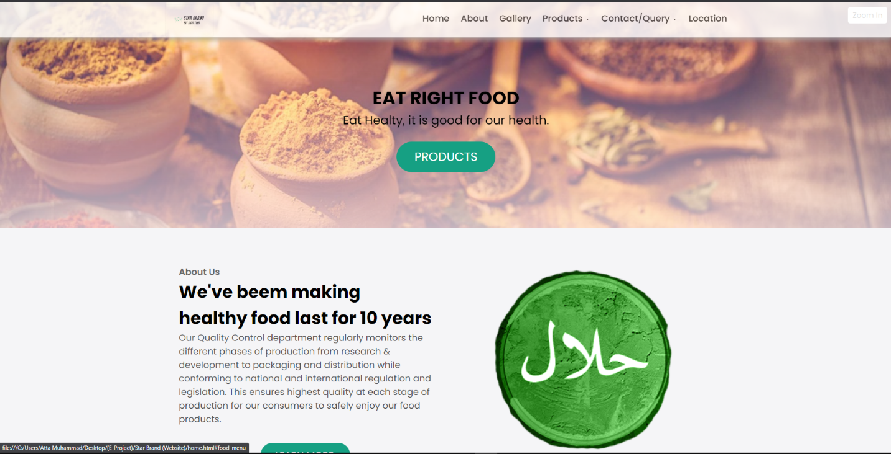

***Figure 1.1(Home Page)***

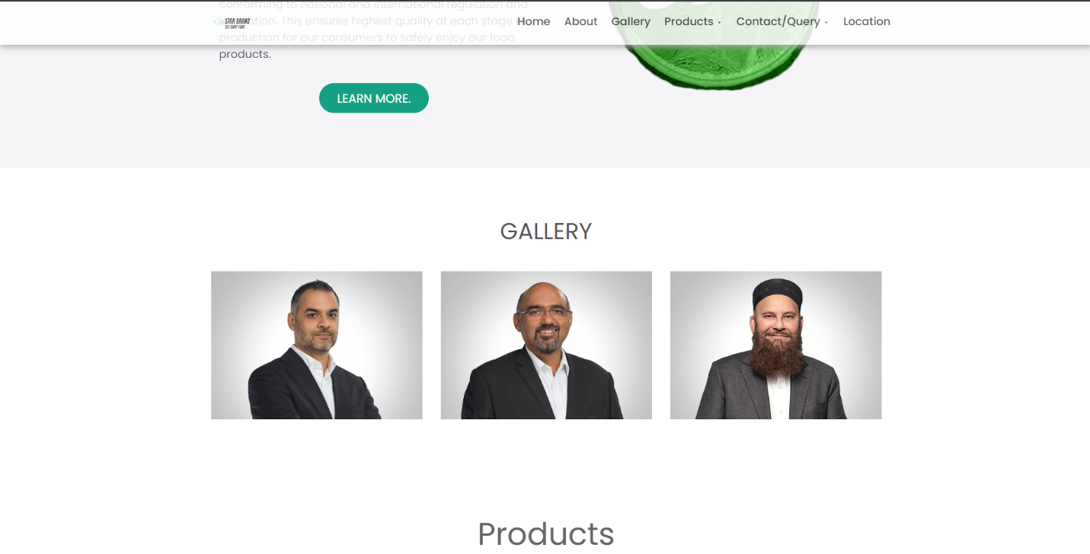

***Figure 1.2(Home Page)***

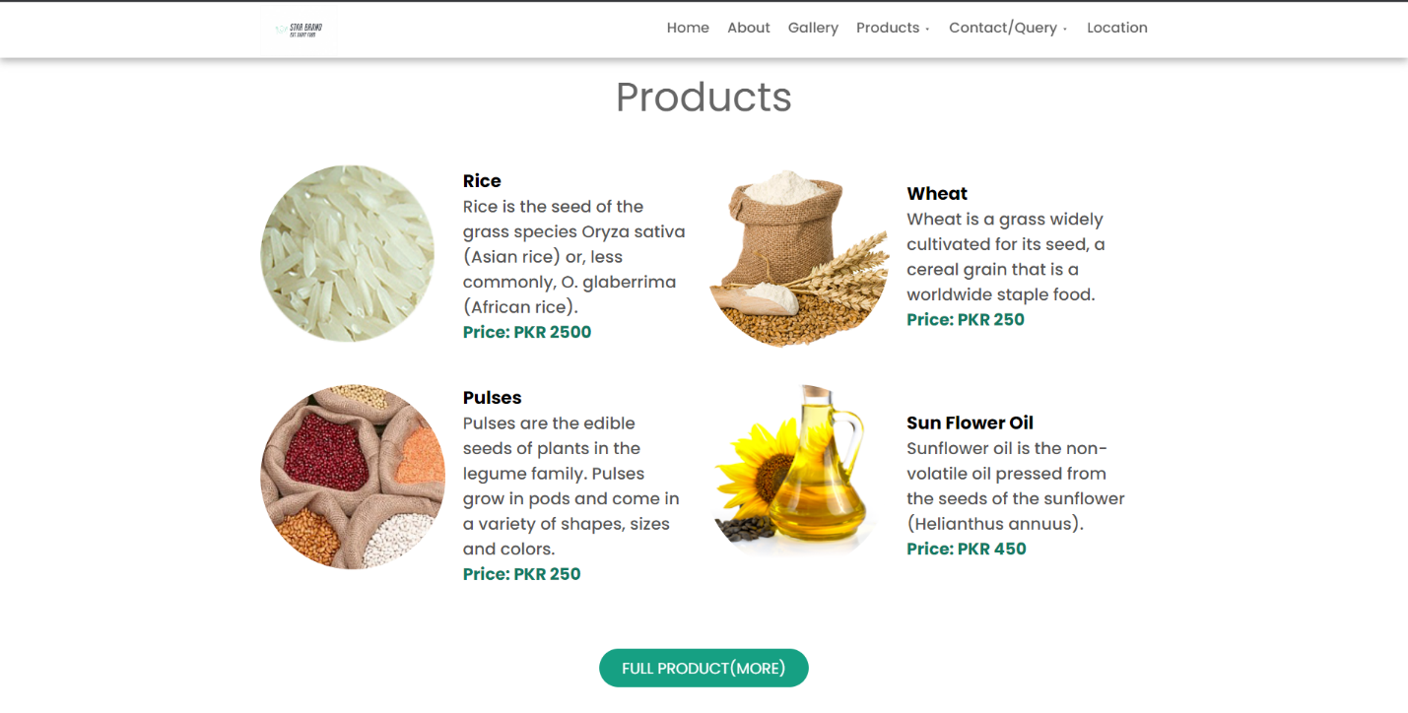

***Figure 1.3(Home Page)***

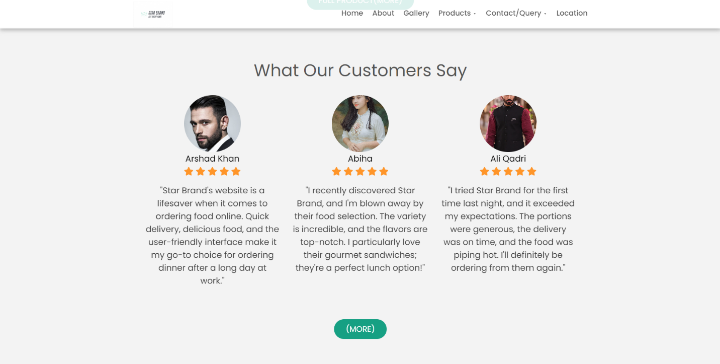

***Figure 1.4(Home Page)***

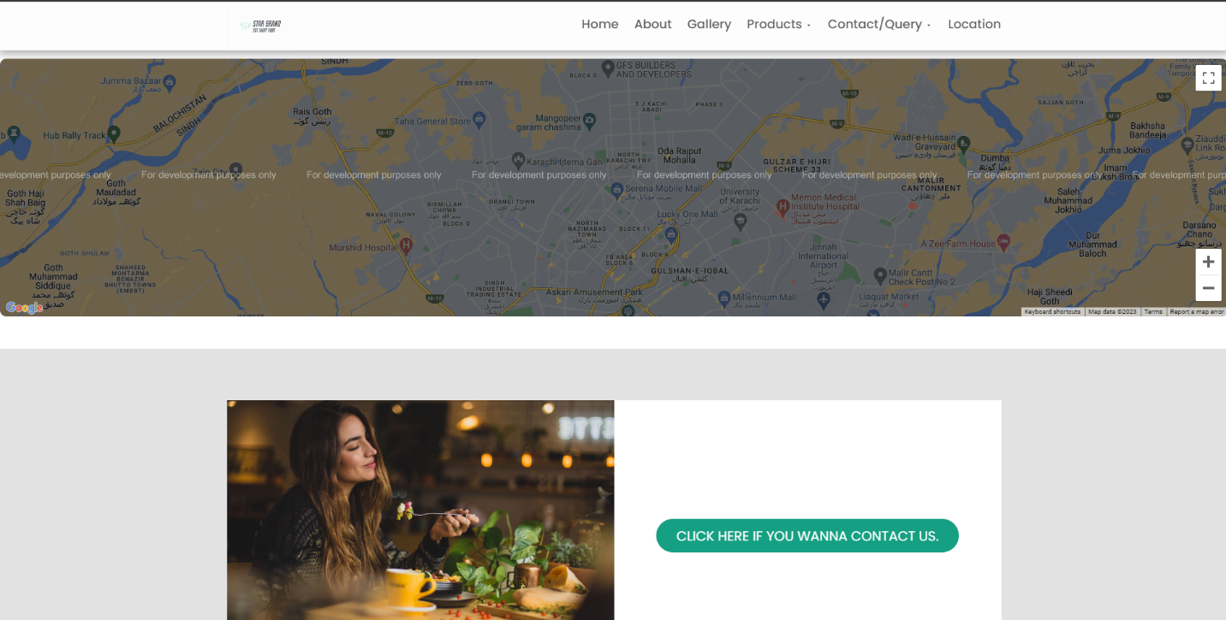

***Figure 1.5(Home Page)***

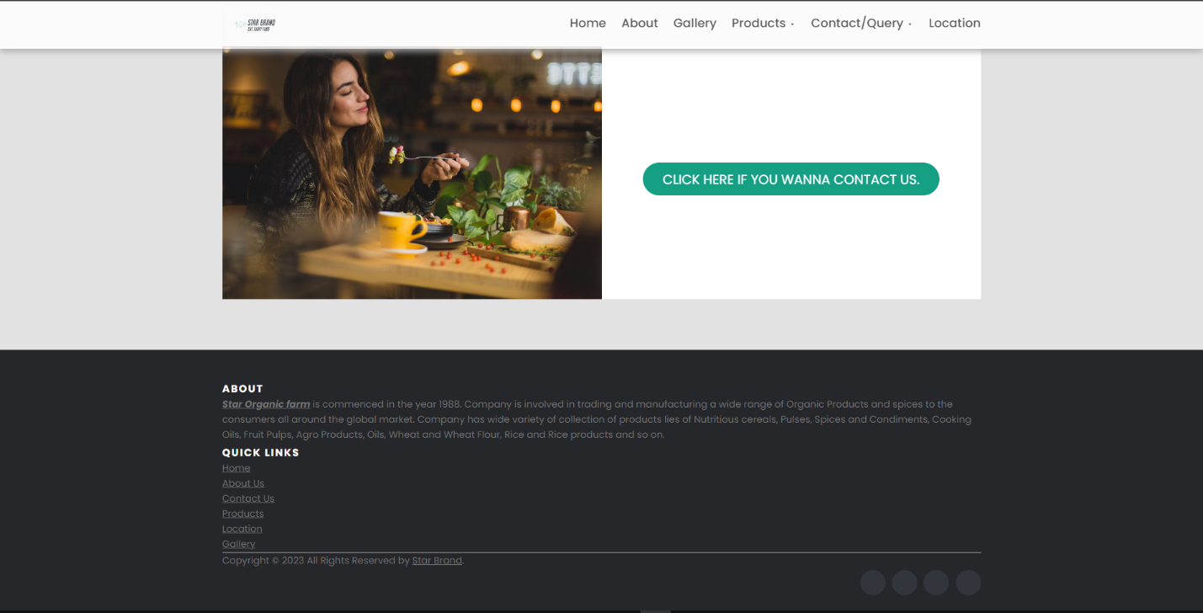

***Figure 1.6(Home Page)***

1. ***Home Page Options :-***

***A .Navigation Bar :-***



***Figure 2.1(Navbar)***

The footer contains two main sections within a container. In the first section, there is a brief description of the company, "Star Organic Farm," which was established in 1988. This company is involved in trading and manufacturing a wide range of organic products and spices for consumers in the global market. They offer a diverse collection of products, including nutritious cereals, pulses, spices, condiments, cooking oils, fruit pulps, agro products, oils, wheat and wheat flour, rice, and rice products. The description is presented in an emphasized style with italics, bold, and underlining.

The second section, "Quick Links," provides easy navigation links to different parts of the website. These links include "**Home**," "**About** **Us**," "**Contact** **Us**," "**Products**," "**Location**," and "**Gallery**." These links are helpful for users to quickly access the main pages or sections of the website.

Towards the bottom of the footer, there is a copyright notice, indicating that all rights are reserved by "Star Brand" for the year 2023. This is a common legal statement to protect the content and design of the website.

Lastly, the footer includes social media icons with links to the company's profiles on platforms like Facebook, Twitter, Dribbble, and LinkedIn. These icons allow users to connect with the company on social media platforms for updates and engagement.

***Logo :-***

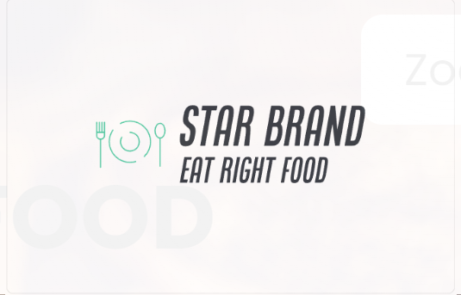

***(LOGO)***

***Buttons In Navigation Bar :-***



***No.1 Home(home.html)***

***No.2 About(about.html)***

***No.3 Gallery(Category.html)***

***No.4 Products(MENU.HTML)***

1. ***Rice(rice.html)***
2. ***Wheat (wheat.html)***
3. ***Oil(oil.html)***
4. ***Pulses(pulses.html)***
5. ***Fruit Pulps(ruitpulps.html)***
6. ***Spices(spices.html)***
7. ***Carels(carels.html)***
8. ***Agro Products(agro.html)***

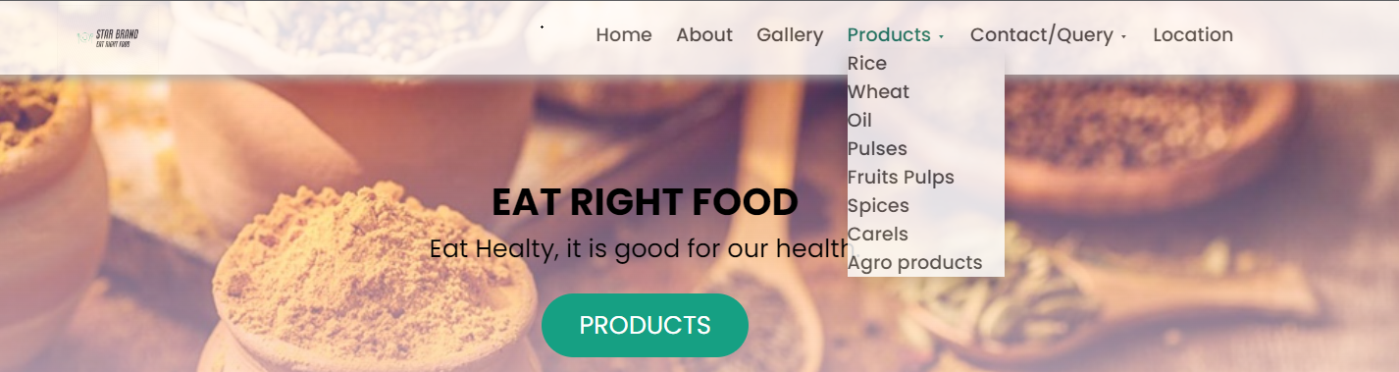

***No.5 Contact/Query(contact.html)***

1. ***Contact Us(conta.html)***
2. ***Query(query.html)***

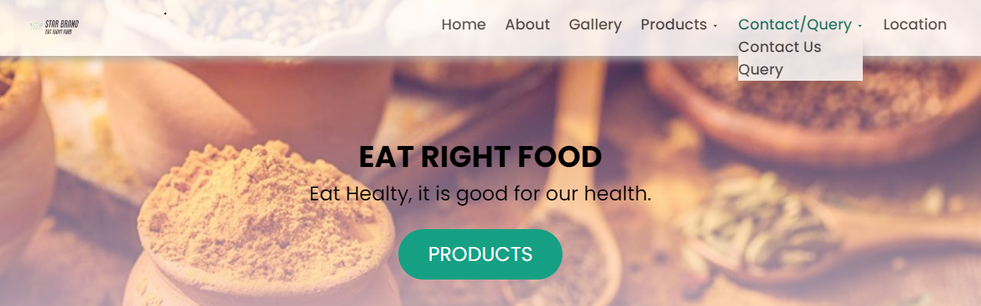

***No.6 Location(map.html)***

***B .Footer :-***

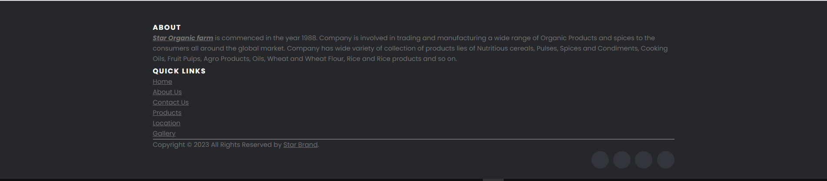

***Figure 2.2(Footer)***

The footer contains two main sections within a container. In the first section, there is a brief description of the company, "Star Organic Farm," which was established in 1988. This company is involved in trading and manufacturing a wide range of organic products and spices for consumers in the global market. They offer a diverse collection of products, including nutritious cereals, pulses, spices, condiments, cooking oils, fruit pulps, agro products, oils, wheat and wheat flour, rice, and rice products. The description is presented in an emphasized style with italics, bold, and underlining.

The second section, "Quick Links," provides easy navigation links to different parts of the website. These links include "**Home**," "**About** **Us**," "**Contact** **Us**," "**Products**," "**Location**," and "**Gallery**." These links are helpful for users to quickly access the main pages or sections of the website.

Towards the bottom of the footer, there is a copyright notice, indicating that all rights are reserved by "Star Brand" for the year 2023. This is a common legal statement to protect the content and design of the website.

Lastly, the footer includes social media icons with links to the company's profiles on platforms like Facebook, Twitter, Dribbble, and LinkedIn. These icons allow users to connect with the company on social media platforms for updates and engagement.

***Buttons Of Quick Link :-***

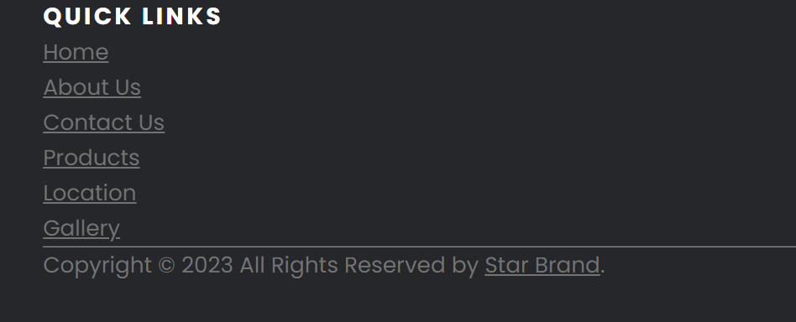

***Figure 2.3(Quick Link)***

* **Home**: This link likely directs users to the homepage of the website, which serves as the main entry point.
* **About**: Clicking this link would take users to a page that provides information about the company or organization, including its history, mission, and values.
* **Gallery**: Selecting this link would lead users to a page displaying a collection of images or visual content, which could include photos, artwork, or other media related to the website's subject matter.
* **Products**: This link appears to connect users to a page where they can explore and browse the products offered by the company. The "Products" page may include listings and details of various product categories.
* **Contact**: Clicking on this link probably takes users to a page with contact information, such as phone numbers, email addresses, and a contact form, to facilitate communication with the company.
* **Location**: This link likely leads to a page displaying information about the company's physical location or locations, possibly on a map.

These "Quick Links" serve a crucial role in providing users with immediate access to key areas of the website. It allows for efficient navigation, enabling users to quickly find the information or pages they are most interested in without having to search through the website extensively. This can enhance the user experience and help users find the content or services they need with ease.

1. ***Product :-***

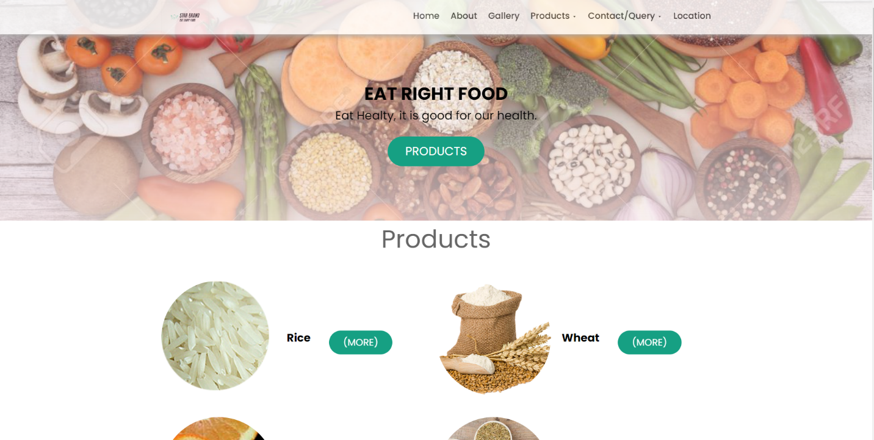

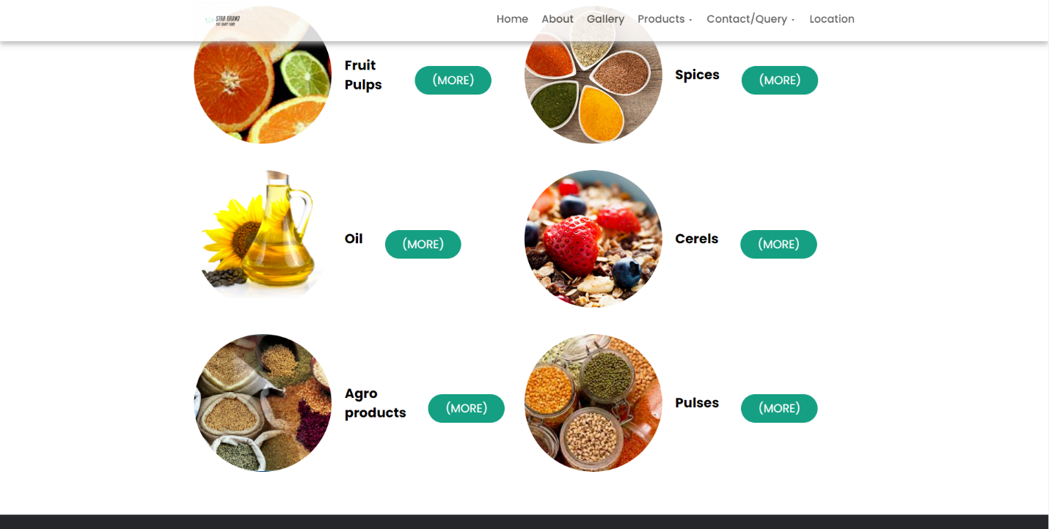

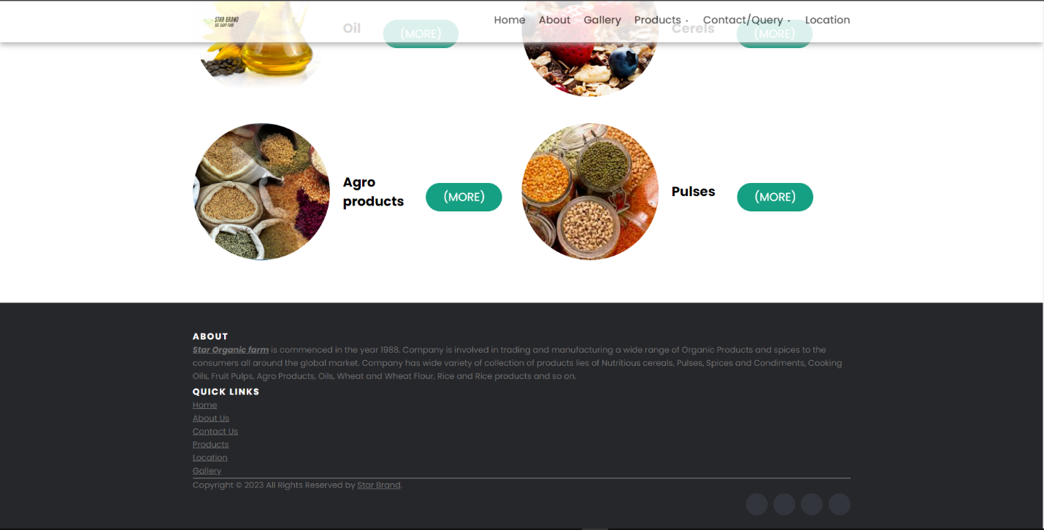

These "Quick Links" serve a crucial role in providing users with immediate access to key areas of the website. It allows for efficient navigation, enabling users to quickly find the information or pages they are most interested in without having to search through the website extensively. This can enhance the user experience and help users find the content or services they need with ease.

* **Product Image**: A product image (<img>) is included, which visually represents the product. In this code snippet, various images are linked to products such as rice, wheat, fruit pulps, spices, oil, cereals, agro products, and pulses. The alt attribute in each image tag should ideally provide a descriptive alternative text for accessibility and SEO purposes.
* **Product Title**: The product's title is displayed as an h2 element with the class "food-titile." The title provides a clear and concise label for each product.
* **"More" Button**: A button with the class "btn btn-primary" and the text "(More)" is included for each product. This button typically links to a dedicated page or more information about the respective product. The href attribute in each button links to the relevant product page.

The "Products" section is versatile and can be adapted to showcase different types of products or services. It serves as an effective way to visually present products and provide quick access to additional details. Users can click on the "More" buttons to learn more about each product. This section is especially useful for e-commerce websites, product catalogs, or service listings where users need a convenient way to browse and explore available offerings.

***List Of My Product :-***



1. ***Rice***

***Description****: Rice is a staple food consumed by people all over the world. It comes in various varieties and is a primary source of carbohydrates.*

Button Label*: "(More)"*

Linked Page*: "rice.html"*

1. ***Wheat***

***Description****: Wheat is a cereal grain known for its versatility. It's used to make a wide range of products, including bread, pasta, and pastries.*

Button Label*: "(More)"*

Linked Page*: "Wheat.html"*



1. ***Fruit Pulps***

Description*: Fruit pulps refer to the processed form of fruit that can be used in various culinary applications, such as making smoothies, jams, and desserts.*

ButtonLabel*: "(More)"*

LinkedPage*: "Fruits Pulps.html"*

1. ***Spices***

Description*: Spices are aromatic substances used to flavor food. They can add unique flavors and aromas to a variety of dishes.*

ButtonLabel*: "(More)"*

LinkedPage*: "Spices.html"*

**

1. ***Oil***

Description*: Oil is an essential cooking ingredient used for frying, sautéing, and as a base for many recipes. Various types of cooking oils are available.*

ButtonLabel*: "(More)"*

LinkedPage*: "Oil.html"*

1. ***Carels***

Description*: Cereals are grains like oats, corn, and barley, often used as breakfast foods, in baking, or for making cereals and porridge.*

ButtonLabel*: "(More)"*

LinkedPage*: "Cerels.html"*

**

1. ***Agro Porducts***

Description*: Agro products typically refer to agricultural products such as fruits, vegetables, and other crops. They can include a wide range of items.*

ButtonLabel*: "(More)"*

LinkedPage*: "Agro Products.html"*

1. ***Pulses***

Description*: Pulses are a category of legumes that include lentils, beans, and chickpeas. They are a good source of protein and fiber.*

ButtonLabel*: "(More)"*

LinkedPage*: "Pulses.html"*

This list serves as an example of the products featured in the "food menu" section of your website. You can expand or modify this list to match the actual products available on your website and provide detailed descriptions and links for each product to help users navigate and make informed choices.

1. ***Product (Order Now) :-***

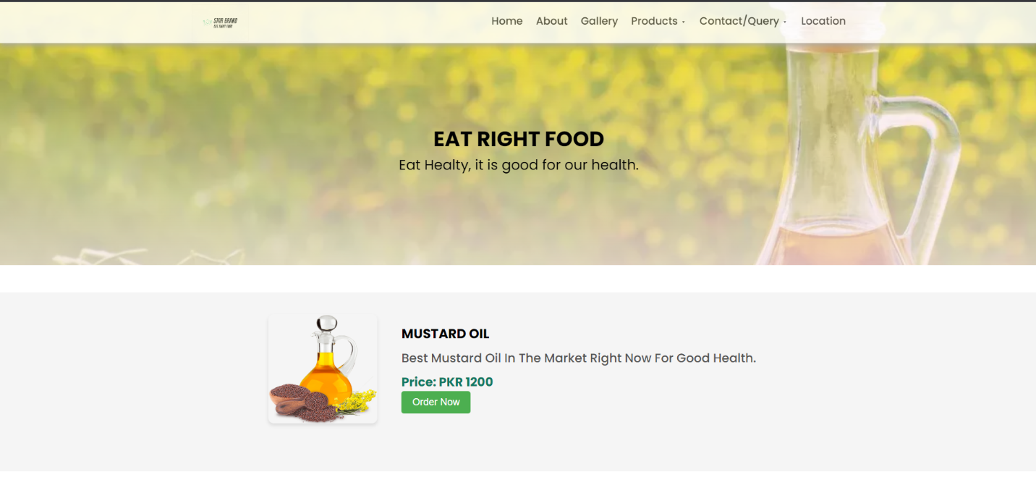

***(Order Page)***

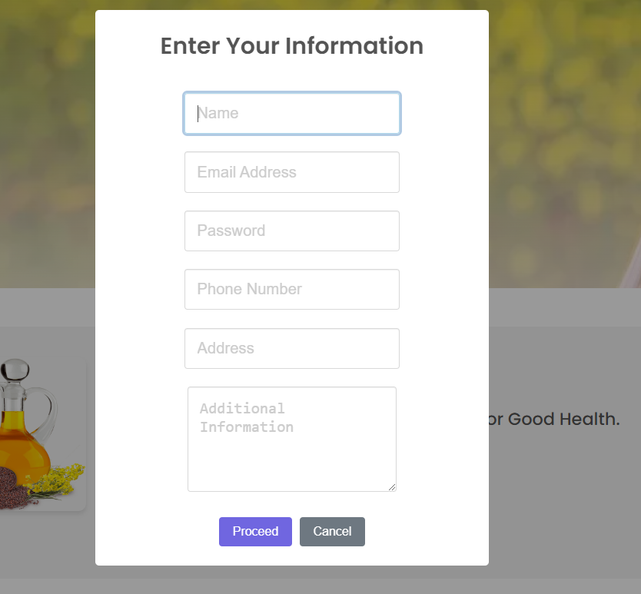

***(Form)***

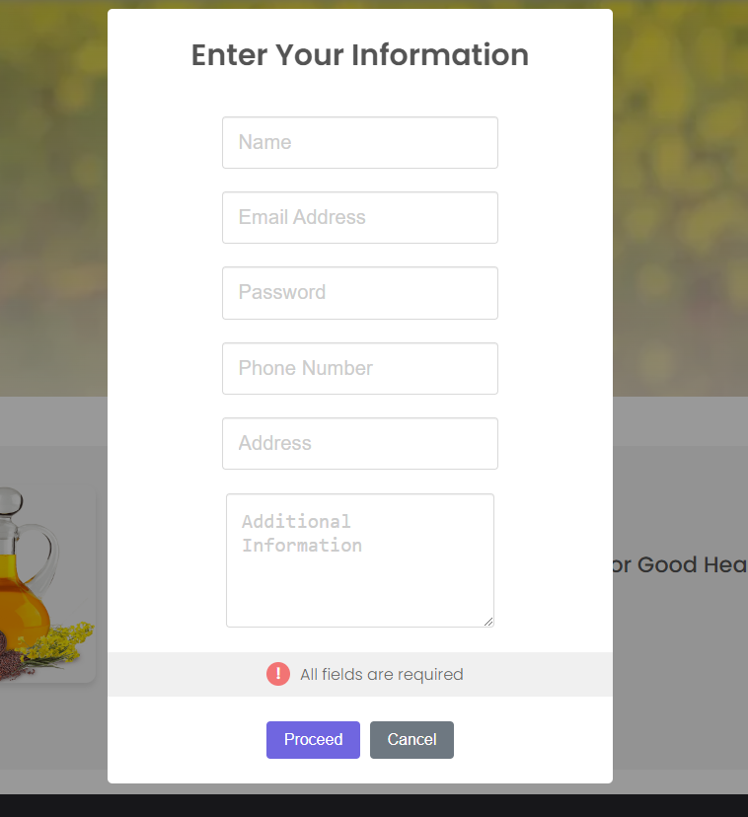

***(Validation)***

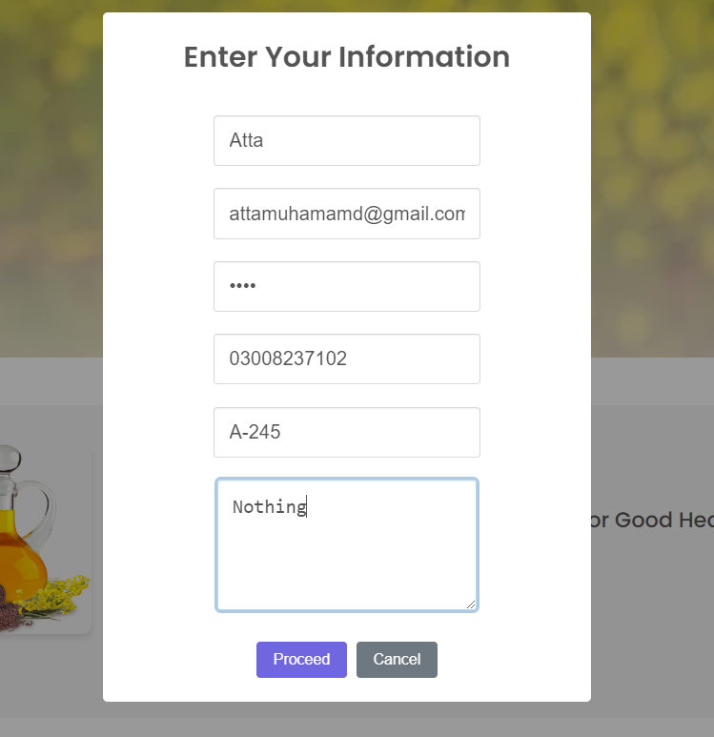

***(Correct form)***

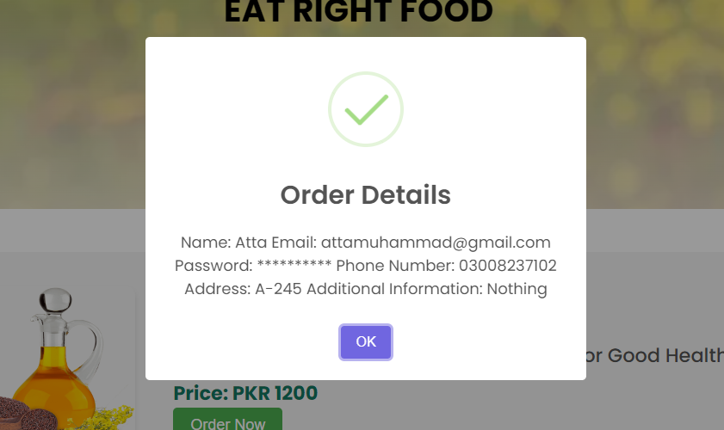

***(Order Confirm)***

***HTML Section (Product Presentation):-***

* The HTML section with the ID "garlic-paste" is responsible for presenting detailed information about the "Mustard Oil" product. It includes various elements that create a structured product presentation.
* **Product Image**: An image representing the product, "Mustard Oil," is displayed using the <img> element. The image is titled "Garlic Paste," and its height and width are set to 200 pixels for proper display.
* **Product Title**: The product title is presented as "MUSTARD OIL" and is enclosed within an <h2> element with the class "food-title."
* **Product Description**: A brief product description is provided in a <p> element, explaining that this is the "Best Mustard Oil In The Market Right Now For Good Health."
* **Price**: The price of the product is displayed as "Price: PKR 1200" within a <p> element with the class "food-price."
* **Order Button**: An "Order Now" button is included, labeled with the class "order-button." It's associated with a JavaScript function called "showOrderForm()".

***JavaScript for Order Form :-***

* The JavaScript function "showOrderForm()" is responsible for showing a pop-up order form using the SweetAlert2 library (Swal).
* ***User Input Fields***: The pop-up form includes various input fields for collecting user information, such as name, email, password, phone number, and address. Additionally, there is a textarea for additional information.
* ***Confirmation Buttons***: Users are presented with a "Proceed" button for confirming their order and a "Cancel" button to cancel the operation.
* ***Validation***: The script performs basic input validation, ensuring that essential fields like name, email, password, phone number, and address are filled out. If any of these fields are missing, a validation message is displayed.
* ***Order Confirmation***: After successful input and validation, the order details, including name, email, obfuscated password, phone number, address, and additional information, are displayed in a success message.

***External Libraries and Dependencies :-***

The user guide should mention the use of external resources, specifically the jQuery library and the SweetAlert2 library, both referenced using script tags and links to stylesheets. These libraries provide the necessary functions for displaying the order form and handling user interactions.

***Thank You For Reading The Documentation.***

***Please Follow The Instruction s Above !!***